***The St. Paul's Chronicle***

St. Paul's Anglican Church

54 St. Paul's Crescent,

Barrie, Ontario, L9J 0E2

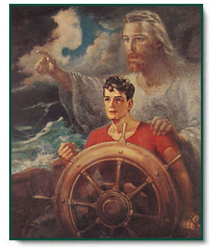

“Christ our Pilot” by Warner Sallman

The Lord gives guidance to all

Especially those in peril.

June – August, 2019

Volume 3, Edition 2

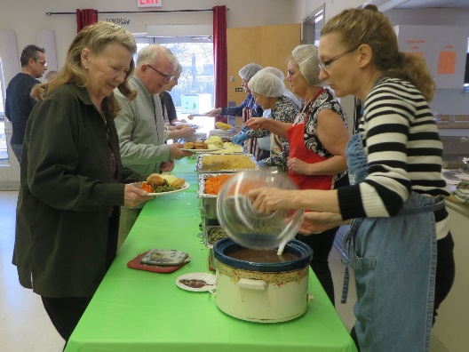**Fabulous Phyliss’ Special Roast Beef Dinner – March 23, 2019**

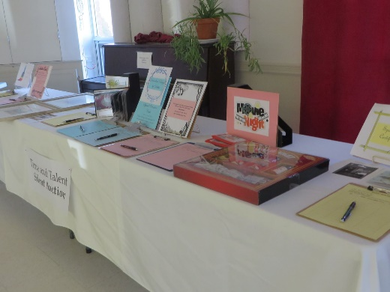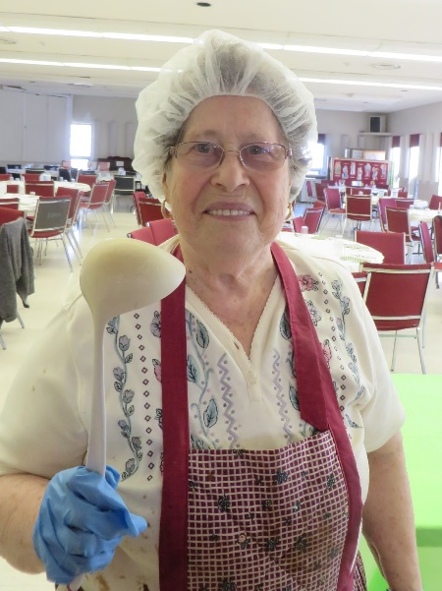

Left: Phyliss Crews, the chief organizer and chef of the dinner.

Above: The Silent Auction table and dinner being served.

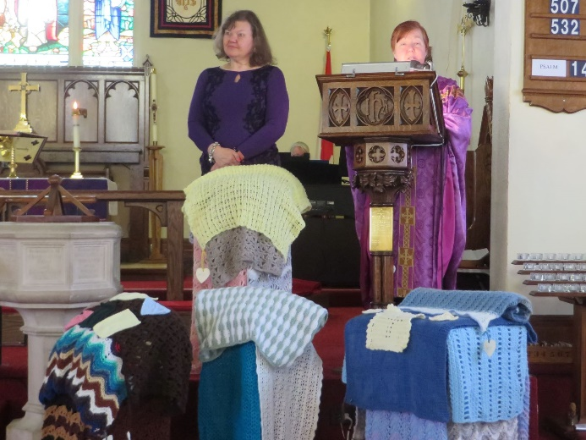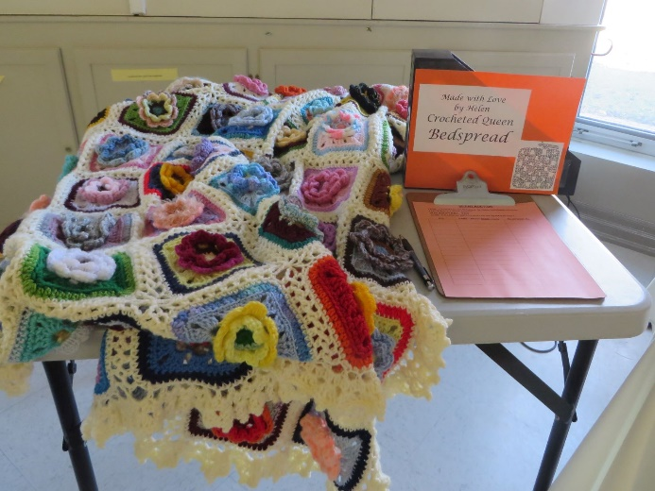Below: The draw quilt done by Helen Steenkamer-Punshon and the Blessing of the Prayer Shawls (Sunday, March 31)

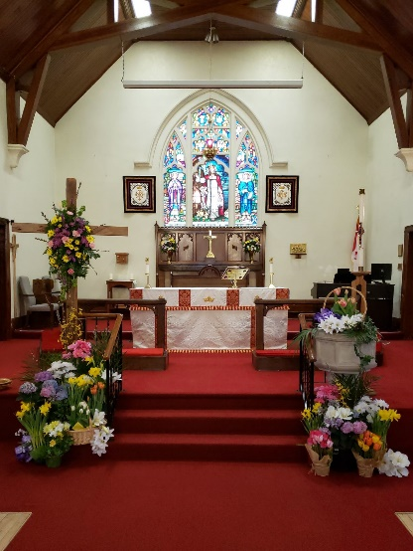

Right: Our Easter

Sunday Chancel.

Beautiful!

**TABLE OF CONTENTS**

Editor's Message (George D. Timpson) Page 4

Debbie’s Desk (The Rev. Debbie Dennis) Page 5

Message from the Rector's Warden (Marilyn Hutchinson) Page 8

St. Paul’s Re-gathering Dinner Page 10

Message from the Peoples’ Warden (Mike Sindrey) Page 11

Financial Churchwarden's Report (George D. Timpson) Page 12

Special Vestry Meeting Page 14

Books 'n Things in the Library (Ann Timpson) Page 15

New Items in the Library (Ann Timpson) Page 16

Special Events Report (Marilyn Hutchison) Page 18

Plant Sale Extravaganza (Mark & Kathy Hall) Page 19

Some Old Boy Scout Lore (Frank Little) Page 20

Electronic Recycle Month (Marilyn Hutchison) Page 20

The Prayer Shawl Ministry (Helen Steenkamer-Punshon) Page 22

St. Paul's Dart Club (Frank and Queenie Little) Page 23

How’s that Again? (Ann Timpson) Page 23

Whodunit? (Ann Timpson) Page 24

A Communion Prayer Page 25

Calendar of Events for the Next Three Months Page 26

The Children's Colouring Pages Page 29

**\* * * * * * * * * * * * * * \***

**WHO TO CALL AT ST. PAUL'S**

The Rev. Debbie Dennis, Incumbent: 705-726-1896

Interim Priest-in-Charge: (April 28 to September 22, 2019)

The Rev. Joanne Bennett, 705-734-0321

Marilyn Hutchison, Rector's Warden, Special Events: 705-791-6866

Mike Sindrey, People's Warden, Property Committee, Custodian: 705-817-5081

George D. Timpson, Deputy Rector’s Warden, Financial Churchwarden & Editor of *The Chronicle*: 705-294-1657

Siobhan Duncan-Kemp, Deputy Peoples’ Warden: 705-252-3500

Cathy Turgeon, Envelope Secretary, Church Receptionist: 705-431-0343

Church Office: 705-722-7755

Email: office@stpaulsinnisfil.com

Website: www.stpaulsinnisfil.com

Facebook: St. Paul's Anglican Church, Innisfil

**EDITOR'S MESSAGE**

**by George D. Timpson**

Dear St Paulians,

This is the seventh edition of *The St. Paul’s Chronicle*.

This issue deals primarily with the summer months of June, July and August. I hope that you and your loved ones are able to get away for some time to relax during part of this time frame.

Ann and I will leave our home on Saturday, June 8, 2019, and we will fly to Heathrow International Airport in London, England, and then to El Prat International Airport in Barcelona, Spain. We will spend the night of June 9th at the Roi Juan Carlos Fairmont Hotel in Barcelona, and partake of a gala reception and dinner for those participants in the Silversea Grand Mediterranean Voyage. On June 10th we will embark the Silversea line *ms Silver Shadow* to start a 47-day trip around the Mediterranean visiting 39 ports in 9 countries. We fly home on Saturday, July 27th from Barcelona, again via way of Heathrow Airport. We will get home late on July 27th and will need to start a “vacation to recover from our vacation”! We will effectively be back in action by the July 31!

During this time that we are away, Rev. Debbie will also be on her Sabbath Leave. Rector’s Warden Marilyn Hutchison, who is also my assistant in looking after the financial affairs of St. Paul’s, will take charge locally of all matters financial. I will still be able to monitor what is happening in this regard from the ship during my absence.

On behalf of everyone, I want to thank the Rev. Joanne Bennett and Marilyn Hutchison for their work in filling in for those of us who are away, in addition to their regular responsibilities. Thank you !!!

September 1st will mark the release of the next edition of *The Chronicle.* It will cover the months of September, October and November. The theme will be the restart of our Christian work within St. Paul’s, the beautiful season of Autumn, Thanksgiving, Remembrance Day, and getting ready for the Church season of Advent. Rev. Debbie will return from her Sabbath Leave on Sunday, September 22nd.

I want to thank Rev. Debbie and my wife, Ann, for many of the photographic contributions found herein.

The next **deadline** for submitting articles and photographs for this eighth issue of *The* *Chronicle* will be **Friday, August 16, 2019**. Earlier submission of material is always welcome and greatly appreciated.

As I have tried to stress before, if you would like to submit something to this newsletter, then please let me know. You can send it to me as an email attachment to [gtimpson@rogers.com](mailto:gtimpson@rogers.com) or hand it to me as a handwritten note and I will type it out for you.

For the record, this edition consists of 7,359 words.

**\* * * * * * * * * * * * * * \***



**DEBBIE’S DESK**

**by The Rev. Debbie Dennis**

I write this column with one week to go before I arrive in Florence, Italy. And I am flooded with emotions. As a child, our family did not have the means to take holidays, never mind cultural trips to Europe. As an adult, I have been blessed to travel but never to see the art and the sacred sites that I will on my Sabbath Leave. When I ponder how to explain this “bucket list” holiday I keep returning to a quote by St. Iraneus: **The glory of God is the human person fully alive.** In beauty, in human creativity, in art and architecture I believe we see praise for the God who gives us life and grounds us. Especially in the Renaissance, I have learned that we see science and faith kissing to produce glorious results. I cannot wait to see it for myself!!

To finally be able to stand before some of the works of art that I have only seen in reference books, I imagine, will be overwhelming. Raphael, Donatello, Michelangelo, Brunelleschi, Ghiberti …

## The famous Duomo (Cathedral) of Florence has always held a special allure for me. It is the city’s geographical and spiritual center, with its red dome visible from all over Florence. I share with you some information found on the website of the **Cathedral of Santa Maria del Fiore** and from Rick Steve’s travel commentaries.

## **History & Architecture**

The Florence Cathedral that we see today is a culmination of artistic imaginations of many great artists and architects. Arnolfo di Cambio submitted the design for the Cathedral in the year 1296, and its construction began under the supervision of Francesco Talenti. The Church was consecrated by Pope Eugene IV in 1436 after the completion of the Dome, designed by Filippo Brunelleschi. The fresco on the inside of the dome depicts the Last Judgement and was painted in colourful strokes by Giorgio Vasari and Federico Zuccari between 1572 and 1579.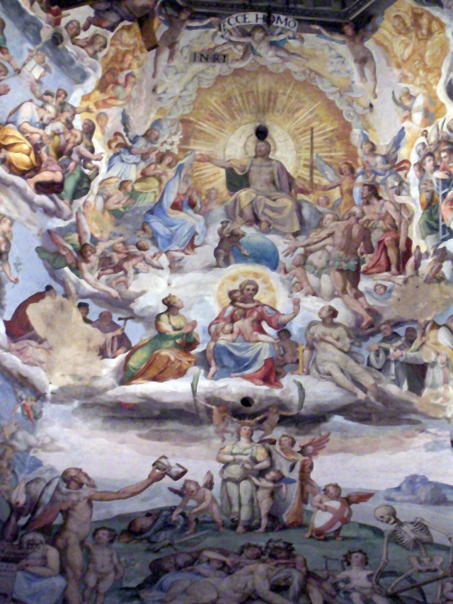

The beautiful designs in white, pink, and green marble that form the façade of the Cathedral was added between 1871 and 1887. It complements the bell tower which was designed by Giotto di Bondone in 1334 but it was completed first by Andrea Pisano, who also designed the relief decorations on the tower. Later, Francesco Talenti oversaw its construction and was finally completed in 1359.

What is so fascinating about this church is that it was constructed without the ability to complete it – begun in 1296 yet by the 1400s there was still no suitable roof! In other words, firmly convinced in the possibilities of human ingenuity, the Florentines built a cathedral and were content to wait until someone figured out how to construct a dome large enough and spectacular enough (a span of 140 ‘) to enclose their church! By 1436 Filippo Brunelleschi would cap the octagonal hole with a Roman style dome as grand as the Pantheon which he had studied. It is essentially a free-standing dome within a dome. Built in only 14 years, it was the wonder of the age and became the model for many domes to follow, from St. Peter’s to the U.S. capitol. Michelangelo, setting out to construct the dome of St. Peter’s drew inspiration from the dome of Florence. He said, “I’ll make its sister…bigger, but not more beautiful.”

More courageous than me, Aaron is going to climb the dome and get the best aerial views of Florence.

*(Editor’s Comment: Good luck, Aaron, it looks like a steep climb! Can I be on your shoulders? I’m very nervous of anything over 8 feet high!)*

**However, it is the Baptistery that will be my highlight**. The Octagonal Florence Baptistery, the Baptistery of Saint John, is one of the oldest buildings in the city, constructed between 1059 and 1128 atop of Roman foundations.

What I am excited to see is the Baptistery’s interior. Workers from St. Mark’s in Venice came her to make the remarkable ceiling mosaics (of Venetian glass) in the late 1200’s. The most famous is *The Last Judgement* which gives us a glimpse of the medieval worldview. Life was a preparation for the afterlife, when you would be judged and saved or judged and damned. Christ, peaceful and reassuring, blesses those at his right hand with heaven (thumbs up) and sent those to his left to hell (the ultimate thumbs down.)

Even more than the ceiling, the famous bronze doors by Ghiberti have always captured my imagination. The Renaissance began in 1401 with a citywide completion to build new doors for the Baptistery. Lorenzo Ghiberti won the job and built the doors for the north side of the building. So popular were they that he was contracted to make another set of doors for the east entrance facing the Duomo. These bronze “Gates of Paradise” revolutionized the way people saw the world around them. Each panel is bronze with a layer of gold on top. They tell several stories in one frame using perspective and realism as never before. Ten great Old Testament stories are depicted. I have already apologized in advance for embarrassing my travel companions because I am sure I will burst into tears when I finally see them! (They are no longer hanging on the Baptistery. They have been moved to the Duomo museum for protection …. which will be another pleasure to tour.)

I have been fascinated with the Renaissance since my early twenties and approaching my sixtieth birthday I am finally going to see these great and timeless works of art. I feel so incredibly blessed. Thank you to Rev. Joanne, our churchwardens, and you, the people of St. Paul’s, for agreeing to give me time to rest and renew and be inspired!

I close with some quotes I like about travel and beauty.

**“I am not the same, having seen the moon shine on the other side of the world.” ~ Mary Anne Radmacher**

**The real voyage of discovery consists not in seeking new landscapes, but in having new eyes.” ~ Marcel Proust**

**“Travel makes one modest, you see what a tiny place you occupy in the world.” ~ Gustave Flaubert**

**“There is nothing that makes its way more directly to the soul than beauty.” ~ Joseph Addison**

**“Never lose an opportunity of seeing anything beautiful, for beauty is God's handwriting – a wayside sacrament.” ~ Ralph Waldo Emerson**

**\* * * * * * * * * * * * * * \***

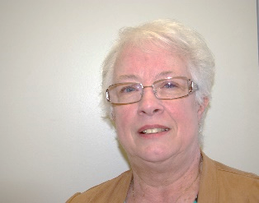

**RECTOR'S WARDEN'S MESSAGE**

**by Marilyn Hutchison**

Spring has sprung and St. Paul’s has a lot going on.

As I look back on the last few months and what is currently happening. St. Paul’s is blessed with volunteers who have contributed their time and energy to keeping St., Paul’s running as well as it does, and making it possible for St. Paul’s to do all we do.

Signage designating recycle bins and garbage bins have been hung in the kitchen to facilitate the separation of material that we can recycle. Food waste after dinners is also being recycled; St. Paul’s is making a difference.

Pew books were mended and organized and new shelving was provided to the library for more books.

Who would have thought St. Paul’s loved pancakes? Our pancake supper in February was not only fun, it was a huge success.

In March, there was a need to repair the ceiling in the church front foyer and thanks to Mike Sindrey and Brian Harvey for quickly responding to this emergency. The foyer was back in use the following Sunday.

When it was announced that St. Paul’s was in need of a new piano, Phyllis Crews put on her apron and prepared an amazing roast beef dinner as a fund raiser. Thanks to the efforts of Phyllis and her crew; the money need was raised and the piano has been purchased.

An Afternoon Tea & Fashion show held in April provided a fun filled afternoon with fashions from Lilie’s Boutique, modeled by ladies from St. Paul’s.

Chefs, Mike Sindrey & Father Ken Rouguska, hosted a scrumptious Mother’s Day Dinner on May 11th. Well done and thank you to those who assisted in making this day the success it was.

The Plant Sale – oh my……………………it will take at least a week to recover from this amazing event on June 1st. Eleanor Beamish, Mark & Kathy Hall who chair this event annually work tirelessly for weeks getting ready. To all the volunteers who so willingly gave of their time and energy, THANK YOU. Not everyone is willing to give up a warm bed and come out before dawn to be ready for 8:00 a.m.

Thank you to Rev. Joanne as she ministers to St. Paul’s family in the absence of Rev. Debbie during her Sabbath leave. Rev. Joanne is available by appointment and she can be contacted through the office. When Cathy is not in the office, messages are checked on a regular basis.

The Strawberry Supper that was planned for June will **not** be held this year. It is always a challenge to have local strawberries ready and the decision was made to skip it this year.

On June 16th, there will be a SPECIAL VESTRY – There are a number of capital projects that need to be addressed and this vestry will be for a Capital Fundraiser. Included in this capital fundraiser will be a new roof for the parish hall, a security system and planning for upgrades to our elevator to meet provincial code requirements in 2020.

The summer months have several projects planned that include painting the hall and painting the tower room. A banner hanger is being made and donated, to hang our beautiful banners in the choir loft.

Plans for the Sunday school picnic on June 9th are well underway and no matter how old you are, you do not want to miss the BBQ.

By the time the September issue of *The Chronicle* comes out, we will be preparing for our Re-gathering Dinner. Mark your calendars now for September 21st. Posters and announcements will be made closer to the date but plan now to attend.

Your opinion matters and I welcome your input to guide the special events St. Paul’s hosts.

St. Paul’s relies on your financial support over the summer to pay the bills. If you are going to be away, post dated cheques or pre authorized remittance (PAR) would be appreciated.

No matter where you are over the next few months, may Angels go with you wherever you go, and guide you back safely, to family and friends.

**\* * * * * * * * * * * * * * \***

A chip on the shoulder indicates wood higher up.



Mark your calendar now

St. Paul’s Re-gathering Dinner

September 21, 2019 – 5:00 PM

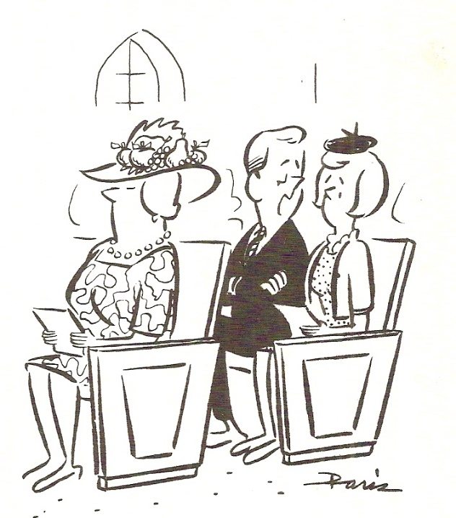

It’s making me hungry!

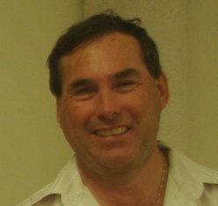**PEOPLES’ WARDEN’S MESSAGE**

**by Mike Sindrey, Property Committee Co-Chair**

Hello Everyone!

As you have probably heard, we will be having a special Vestry Meeting on Sunday, June 16, 2019, to discuss Capital Fundraising to be used for re-shingling the roof on the parish hall, a recording security system, and elevator improvements.

Over the last winter we have lost a lot of shingles as the roof is 30 years old and is the original roof on the parish hall. I am sure we will be able to count on everyone’s support for this.

We will also be considering putting in a proper recording security system as we presently do not have one within the church.

In a recent inspection of our elevator by the TSSA *(Technical Standards and* *Safety Authority, 1996)*, we were informed that in order to meet safety code requirements, there are certain switches, etc., which must be brought up to the elevator code standards in order to qualify for our elevator operating licence in 2020. This year is the last year that our older equipment can be licensed.

The old bathrooms in the basement have been dismantled and turned into much needed storage space. I want to thank George Souter and Brian Harvey for their help in this project.

Other projects underway are building a platform to service the sign at Mapleview Drive and Yonge Street. This will make it much easier to change signs. We will be building storage for the different signs as well.

In July, we will be painting the inside of the parish hall. It is my feeling that we should go with a light grey colour to try to make the room brighter. The help of anyone willing to assist would be greatly appreciated. Many hands make the job go that much quicker.

I would like to wish everyone a great summer. Be safe and enjoy!

**\* * * * * * * * * * * * * * \***

If you keep using my name in vain, I’ll make rush hour longer. God.

**A REPLACEMENT BARBECUE NEEDED**

The church’s present BBQ is starting to be on its last legs! If anyone is moving to a smaller residence and eliminating a BBQ, or purchasing a new BBQ, please let Mike Sindrey know at 705-817-5081.

**\* * * * * * * * * * * * * * \***

**FINANCIAL CHURCHWARDEN'S REPORT**

**by George D. Timpson,**

**Deputy Rector’s Warden**

**PART I: Financial Progress**

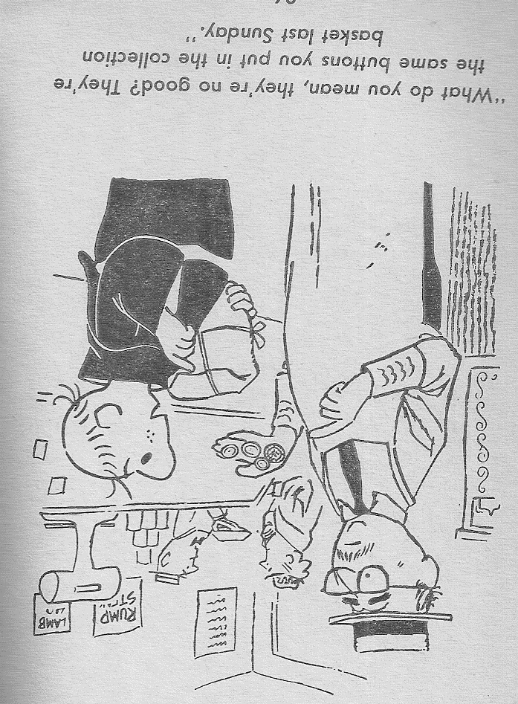I now have the April 30, 2019, complete financial statements, showing our approved budget and actual revenues/expenditures as of the end of April. April 30 means that we are 1/3 of the way through 2019 or 33.33%. Amazing how fast the year is passing by.

Our revenue stream is strong, but with summer coming, I expect things to slow down somewhat, and this could cause some challenges. If you use the PAR (Pre-Authorized Remittance) system, this is a great help, especially if you go away on vacation for a while during the summer. PAR allows the church to receive your collection donation even when you are away, as the church’s expenses do not stop: electricity is still used, grass still grows, and garbage has to be removed, amongst many other ongoing costs of maintaining our beautiful church building.

If you are not using the PAR system, please speak to either me or Marilyn Hutchison, or if we are not available, speak to Cathy Turgeon.

The April 30 figures show that our total income has been $74,456.96, and our expenses in the same period were $64,179.65. This leaves us with a paper budgetary surplus of $11,277.31.

Some of this surplus comes from a very generous memorial donation from the Holdcroft estate, and it has been designated to help pay for the new piano, new candle holders, and the new roof on the parish hall. The piano is now in the church building and is being loaded with the music that it requires.

The roof repair is one of the Capital Fundraising proposals to be considered at the Special Vestry Meeting on Sunday, June 16, and I hope that the congregation will give its approval for all the repair works to be carried out during the summer months.

Up to the end of April, we have been able to reduce the amount owing to the Toronto Diocese by making payments larger than the amount which we are billed each month. Thus, the accumulated debt has been reduced. As I write this message, I am hopeful that we will be able to make the May payment equally as large as we come into the summer months where our revenues often decrease.

The special events that we have held over the last few months, and the Plant, Yard and Garage Sale Extravaganza on Saturday, June 1, have all helped to make our financial year a success so far this year. Your continued support of our church activities is of paramount importance!

I especially want to thank Marilyn Hutchison, Mike Sindrey, Mark and Kathy Hall, Marilyn Jenkinson, Phyllis Crews, and all of their respective teams for the work they have done, and do, to make all of our special events a great success.

In summary, I believe our financial situation is in good condition. Let us all work to try to keep it this way!

**PART II: FundScrip**

We initiated the FundScrip program last October, and to date it has been very successful.

Please use the following table as a guide for the FundScrip due dates.

MONTH DUE DATE CARDS DELIVERED

June Sunday, June 9 Sunday, June 16

July Sunday, July 7 Sunday, July 14

August Sunday, August 11 Sunday, August 18

September Sunday, September 8 Sunday, September 15

October Sunday, October 6 Sunday, October 13

November Sunday, November 3 Sunday, November 10

December Sunday, December 8 Sunday, December 15

I hope that this knowledge of the due dates will be of assistance to you as you support this program. I have tried to avoid long weekends, and to ensure that you have plenty of lead time to prepare for Christmas.

**\* * * * * * * * * * * * * * \***

**SPECIAL VESTRY MEETING**

**to discuss**

**CAPITAL FINANCE PLANNING**

**for**

**Parish Hall Roof Re-shingling**

**Recording Video Security System**

**Elevator to meet TSSA code in 2020**

**on**

**Sunday, June 16, 2019**

**following conclusion of 10:30 AM Service**

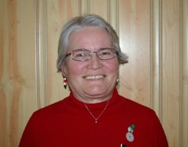**BOOKS ‘N THINGS IN THE LIBRARY**

**by Ann Timpson, Church Librarian**

**Canadians in the Library**

Imagine reading the following in *The Montreal Gazette* back in October,1692:

**VERCHÈRES UNDER SIEGE!!!**

Word has reached Montreal that a band of Iroquois has attacked the Seigneury of Verchères, where only two soldiers form the garrison. The Sieur François Jarret de Verchères, his wife, and their three youngest children are presently here in Montreal, leaving their daughter Madeline (14), and sons Louis (12), and Alexandre (10) back at Verchères. There is also an old retainer, Laviolette, at the fort.

Concern at the situation has led to the dispatching of several soldiers to assist in raising the siege.

If this had appeared in the Montreal newspaper, readers could be forgiven if they thought that Madeline de Verchères helped by keeping the women and children calm in the blockhouse, the central part of the fort, while her brothers assisted the soldiers on the ramparts. If they thought that, they had another think coming! Read *Madeline Takes Command* and you’ll find that she certainly didn’t hide behind the scenes. The soldiers’ idea of what to do in the situation was *to blow up the fort and Madeline just managed to stop them*! Well, read the book, ordinarily kept in our Young People’s section, to see how things worked out. Or perhaps you remember your Canadian history and how the tale ended.

As you may well have noticed, the Library display in the summer is about things Canadian (in honour of Canada Day). This year we look at books and DVDs dealing with Canadian authors and stories. As we have at least 50 items, I can’t list all of them, but since I’ve started with the Young People’s section, I’ll continue with that bookcase. These include titles like *Famous Jerks of the Bible, How We Got the Bible in English,* the above mentioned *Madeline Takes Command, I Walk with a Bishop, Echo Valley, Keeping a Canadian Christmas, Pippin the Christmas Pig,* and *The House of Wooden Santas*. Read these last on a really hot summer day and think cool.

I mentioned DVDs. Several years ago, on Sunday mornings, CTV ran a series of 13 half-hour programmes called *Soul Liberty* which showed the development of Christian thought and history from the fall of Rome to the present. You will find in a green container in the display. Each segment is at least 29 minutes long – no commercials. To end the last disc are two extra programmes: *Men of the Bible* and *I Don’t Want to be Remembered as a Chair* (about the Shakers) The first of the two was written by my mother, Mary Peckover, and performed by men of Siesta Key Chapel, Sarasota FL, where my parents worshipped when, as snowbirds, they wintered in Florida. Indeed, you’ll see my Mom introduced at the end of the show, and my Dad, who was concerned about the man playing Methuselah and assisted him up the aisle. Maybe he’s Mehuselah’s “great-great-great ever-so-many great’s grandson” (to borrow from Rudyard Kipling)!

In our Comparative Religions section (lower two shelves in the Library Annex bookcase behind the door into the Library Proper and the Church Sanctuary), there is a comic book produced by the Royal Ontario Museum called *Adventures of the Magic Monkey along the Silk Roads*. This was put out when the ROM did a display named *Silk Roads and China Ships*, and ends with pictures of artifacts in the show, challenging the reader to find them in the comic pictures. See if ***you*** can find them while enjoying the story!

These are just a few of the many titles by Canadians in the display for June and July. In August and the beginning of September we’ll look at one of our smaller collections to be found in the Library Annex, the two bookcases at the head of the stairs before you get into the Library proper. This display will be about *Art, Architecture, and Crafts* and contains several books on making shawls. Perhaps some of the designs could be useful to the Prayer Shawl ministry

**NEW ITEMS IN THE LIBRARY**

(Thanks to FundScrip and Amazon, the following have now been added)

**Fiddler on the Roof:** Both the film with Chaim Topol and the play on which the movie is based. Be careful, for the disc has two sides. No fingerprints, please!

**Becket:** The play by French author Jean Anouilh on which the movie starring Richard Burton and Peter O’Toole was based. We also have the film on the Adult Movie Shelf.

**Class 9C and the Genesis Time Machine:** A school class travels back in time to the beginning of Creation to find out how the world began!

**Where 2 or 3 Are Gathered Together, Someone Spills His Milk:** A delightful, helpful book in the Humour section of everyday, common, garden-variety problems looked at in a humourous Christian viewpoint, with an equally light-hearted prayer at the end. By the time you’ve chuckled through a couple of chapters, your own conundrums are back into perspective and easier to solve. Take it from someone who knows!

**Jesus of Nazareth:** A movie of the life of Christ. We also have the book which contains stills from the film and text by William Barclay.

**Upon this Rock**: The life of St. Peter. This is a companion volume to **God’s Warrior**, the life of St. Paul. Both are by Frank G. Slaughter, a medical doctor who wrote over 50 novels. Don’t ask me when he had time for his patients!

**A Christmas Special:** Luciano Pavarotti in concert with two Quebec choirs performing at St. Anne de Beaupre Cathedral. Given the ornamentation in the building, it might be hard for us to concentrate on a sermon even as good as we hear from Revs. Debbie or Joanne! WOW!!

**Tamar – a Story of the Messiah:** Jairus’ daughter becomes an ardent follower of Jesus.

**My Lord of Canterbury:** A novel written as if Thomas Cranmer, the first Anglican Archbishop of Canterbury, writes his memoirs the night before he is burned at the stake. A sympathetic biography of a man who many consider to be wishy-washy. He just liked to look at things from all angles before deciding. Cranmer was the only man whom King Henry VIII (and you know what ***he*** was like!) completely trusted.

**David: Warrior and King:** Another book by Dr. Slaughter about the life and work of King David.

**\* * * * * * * * * * * * * * \***



**SPECIAL EVENTS REPORT**

**by Marilyn Hutchison,**

**Special Events Co-ordinator**

**Afternoon Tea & Fashion Show**

St. Paul’s hosted an Afternoon Tea & Fashion show on April 13th.

It was a bright sunny day as we sipped tea, and recalled a popular tea song that was sung by the likes of Doris Day, Tommy Dorsey, Nat King Cole and Frank Sinatra.

Tea for two and two for tea

Just me and you

And you for me……..

Reverend Debbie, our in-house stager, transformed St Paul’s sanctuary into a fifth avenue runway.

Mary Chiarelli laid the table for tea, while Linda Woodworth, Wendy Kirk, Barb Martin and Flo Dament prepared the tea.

Marilyn Jenkinson and Wendy Kirk made, “scones” to accompany petite sandwiches. Marilyn Jenkinson was the “clotted” cream genie; a labour of love.

Tea was announced by the Town Crier, Stephen Travers, who shared some historical facts about St. Paul’s. Stephen was joined by his lovely wife, Linda, who was also attired in period costume. Stephen was very entertaining and even slipped a joke or two in to his repertoire. Thank you Marilyn Jenkinson (MJ) for arranging this treat.

Our models; Barbara Martin, Siobhan Kemp, Francis Oakley Marshall, Cathy Turgeon and Cindy Starinio were attended by our very own makeup artist, Lorraine Schoelles.

The models wore fashions provided by Bradford Garden Gallery’s, Lilie’s Boutique. There were lots of ewwwwwws and awwwwwws as Kat Ward our MC and Eileen from Bradford Greenhouse introduced each model and described the fashions being modeled.

Mike Sindrey’s offer to model was declined but he was kept busy with behind the scene responsibilities.

Thank you to everyone who supported this afternoon event and made it the success it was.

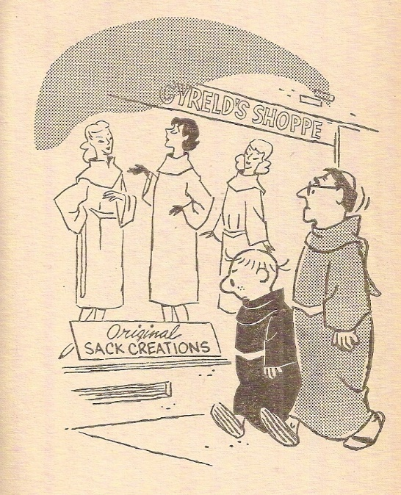

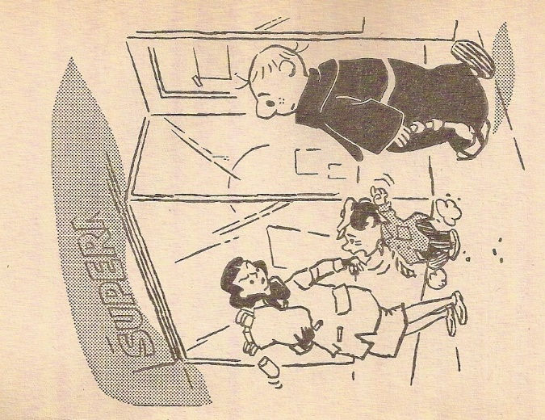

“Why do I hafta tuck in my shirt?

Look at him!”

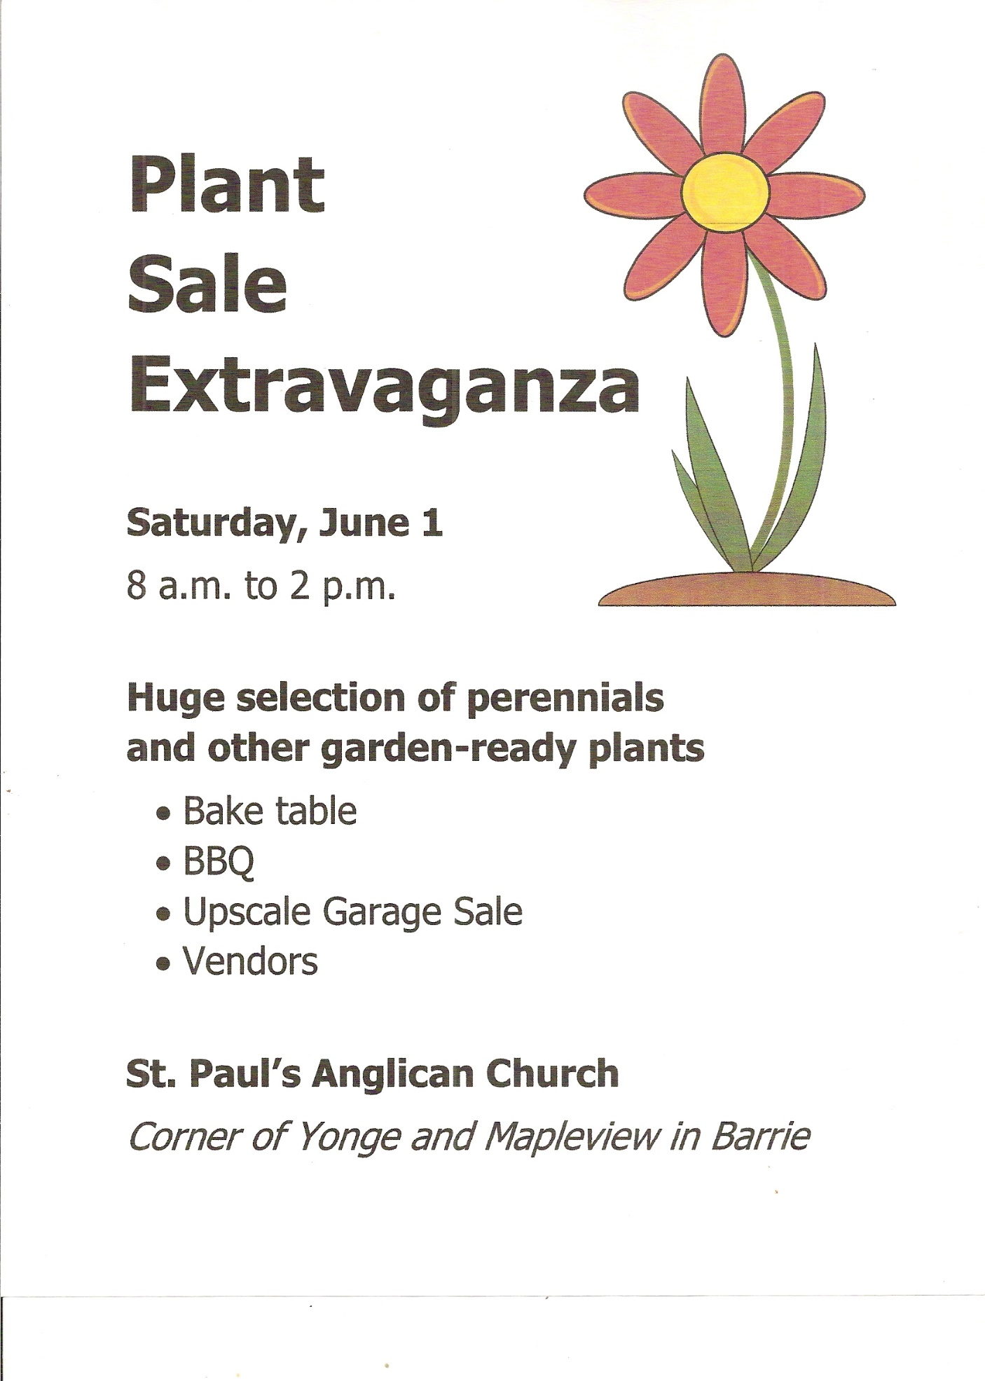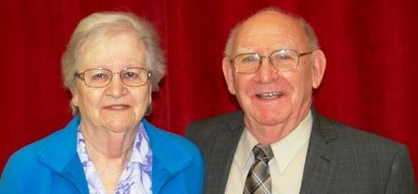**SOME OLD BOY SCOUT LORE**

**by Frank Little, Former Scoutmaster**

We took pride in being self-sufficient by having regular bottle, paper, apple drives, etc., plus special events.

One of our special events was a weekend non-stop ping pong marathon. The Scouts would pick up sponsors. We started at 9:00 AM on Saturday morning and played continuously until 9:00 PM Sunday evening (36 hours in total). The CKBB radio station called in regularly and reported over the air how the event was going. It was good fun and we were completely exhausted at the end!

Another special event was a boxing night. We set up a boxing ring around the four basement support columns. We picked up sponsors and had several exhibition boxing matches. A few friendly grudges were settled among the boys. The odd parent didn’t look too happy when they brought their son home with a bloody nose!

**\* * * * * * * * * * * * * * \***



**ELECTRONIC RECYCLE MONTH**

**organized by Marilyn Hutchison**

**FOR THE MONTH OF JUNE**, you may drop off electronic items in the blue bins located against the fence, near the garage.

On request, I will remove hard drives from computers, sim cards from old cellular phones and destroy them.

Electronics recycling is your opportunity to have a direct impact on the environment. Our electronics are filled with resources – everything from glass and plastic to gold, silver, copper and palladium – that need to be recovered and recycled.

**What is Ontario Electronic Stewardship (OES)?**

Ontario Electronic Stewardship (OES) is an industry-led, not-for-profit organization that operates the regulated recycling program in Ontario. We ensure that end-of-life electronics are handled in a safe, secure and environmentally-sound manner.

**What Can I Recycle?**

https://www.recyclemyelectronics.ca/on/wp-content/plugins/lazy-load/images/1x1.trans.gif

Display Devices

Televisions and monitors, including various technologies such as Cathode Ray Tube (CRT), flat panel (LCD, LED and plasma) and rear projection.

https://www.recyclemyelectronics.ca/on/wp-content/plugins/lazy-load/images/1x1.trans.gif

Non-Cellular Telephones

Includes corded and cordless telephones, as well as telephone answering machines.

https://www.recyclemyelectronics.ca/on/wp-content/plugins/lazy-load/images/1x1.trans.gif

Desktop Computers

Desktop computers (including those acting as servers) and all bundled keyboards, mice, cables and internal components.

https://www.recyclemyelectronics.ca/on/wp-content/plugins/lazy-load/images/1x1.trans.gif

Portable Computers

Includes portable computers such as laptops, netbooks, notebooks and tablets.

https://www.recyclemyelectronics.ca/on/wp-content/plugins/lazy-load/images/1x1.trans.gif

Computer Peripherals

Includes both wired and wireless manual input devices such as keyboards, mice and trackballs.

https://www.recyclemyelectronics.ca/on/wp-content/plugins/lazy-load/images/1x1.trans.gif

Desktop Printers

Printers designed to reside on a work surface, including laser and LED, ink jet, dot matrix, thermal, dye sublimation and “multi-function” copy, scan, fax and print devices. Stand-alone desktop fax machines are also included in this category.

https://www.recyclemyelectronics.ca/on/wp-content/plugins/lazy-load/images/1x1.trans.gif

Personal/Portable Audio/Video Systems

Includes docking speakers, portable stereos, portable CD players, portable audio recorders, tape/radio players, digital media (MP3) players, voice recorders, and digital and video cameras.

* Home Audio/Video Systems

Includes VCRs, DVD and CD players, speakers, amplifiers, receivers, data projectors and similar audio/video systems.

https://www.recyclemyelectronics.ca/on/wp-content/plugins/lazy-load/images/1x1.trans.gif

Home Theatre In-A-Box (HTB) Systems

Includes pre-packaged disc player/speaker/amplifier systems for use with video or television display to create a home theatre experience.

**\* * * * * * * * * * * * * * \***

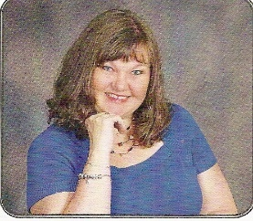**PRAYER SHAWL MINISTRY**

**by Helen Steenkamer-Punshon, Co-ordinator**



This *Chronicle* issue is for the months of June, July and August. I believe that we are supposed to be having spring type weather at this time but Mother Nature seems to be disagreeing with that.

Sigh …

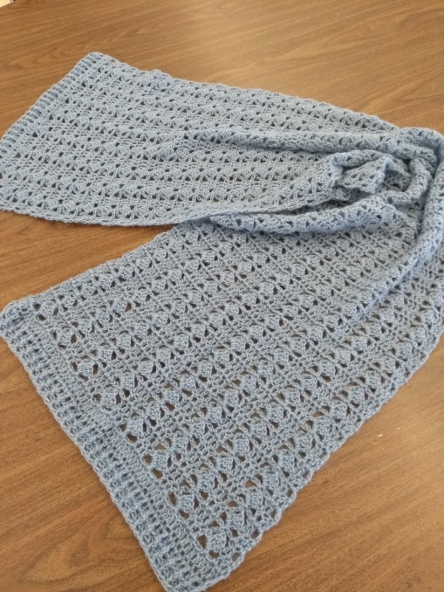We have started to make pocket prayer shawls/cloths. Once blessed, they are placed in a basket on the table just outside the Church. These are little cloths that can easily be put into your purse or pocket to carry with you so that you can connect with it at any time, to give you the sense of receiving love and support and the knowledge that you are never alone. These are free for anyone and can be of great comfort for when you are going to medical appointments, exams, travelling or any time when you can benefit from an extra “hug”.

Our group has been very busy and the shawls are piling up … a lot!!! We would love to gift them to anyone needing an extra little TLC. Please help us out by letting us know of anyone that could use a bit of cheering up; a tangible “hug” to let them know that they are special and that they are never alone.

Perhaps your neighbour, a store clerk who has shared that they are dealing with challenges, someone who has just had a new baby, a milestone birthday or anniversary, is graduating and moving away to attend higher education, someone dealing with separation/divorce/death/health issues, financial stresses, etc. etc. etc.

There is no charge for these shawls, only the desire to help someone else by adding some joy into their life. You can always call, e-mail, or talk to me after the 11:00 a.m. service, leave a message or contact Cathy Turgeon at the reception desk and I will get back to you in order to facilitate getting a shawl to you. Contact info: 705-436-5821, e-mail: [hsteenkamer@yahoo.ca](mailto:hsteenkamer@yahoo.ca)

Wishing you an awesome summer with beautiful sunshine, birds chirping, flowers blooming and hearts full of joy and happiness!!!C:\Users\Owner\AppData\Local\Microsoft\Windows\INetCache\IE\NC76J5SY\red-heart-1362916005N5Z[1].jpg

**Do you crochet?**

The Prayer Shawl Ministry has made available a bag of crochet cotton that is suitable for Christmas decorations or wash cloths.

St. Paul’s Christmas Bazaar would welcome handiwork made from this cotton and every idea is a GREAT idea.

If interested, contact Marilyn Hutchison at 705-791-6866.

**\* * * * * * * * * * * * * * \***

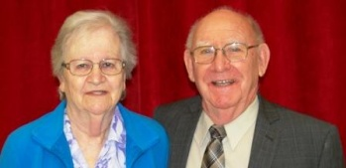

**ST. PAUL'S DART CLUB**

**by Frank and Queenie Little**

St. Paul's Dart Club has been a very active group for over 16 years. We meet on Wednesday afternoons from 1:00 PM to 3:30 PM, with a break for refreshments.

New people are welcome. No experience is necessary. Just bring your own darts and have some fun.

For further information, call Frank or Queenie Little at 705-436-1992.

**\* * * * * * * * * * * * * \***

**HOW'S THAT AGAIN?**

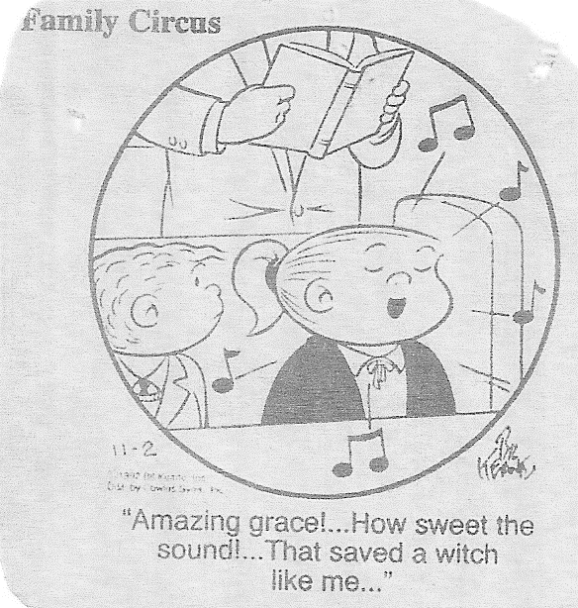The picture on the front cover of this issue of *The St. Paul’s Chronicle* is *Christ Our Pilot* a painting by American artist Warner Sallman. I always think of it when I sing the hymn "Jesus, Saviour, pilot me...". Of course, then I find myself remembering the story of the boy who was so pleased to hear that he would find pastry in Heaven, thinking the line ran "Jesus, save your pie for me"!

Well, I remember learning the first verse of "Holy, holy, holy" (which was, for years, the introduction to the church service) by ear. Sometimes the words "Early in the morning" sounded as if it certainly was -- and we were still waking up! But I thought that "God in Three Persons" was "God in three bird songs" and this made sense, because it's early in the morning that you hear their dawn chorus.

Anyone who has read L.M. Montgomery's *Anne* books will remember that Anne and Marilla take in young twins Davey and Dora. At one time Davey is told that he has taken too much jam on his bread. He sighs and says, "Well, at least there's jam in Heaven!" Asked what he means, he replies, "It says in the Catechism: God makes preserves and keeps us. 'Preserves' is just the holy way of saying ‘jam’.” Marilla mutters something about the hens getting into the vegetable garden (they aren't) and hurries out so that she can sit down and have a good laugh! Meanwhile, Anne explains that Davey has overlooked two commas; the quotation is "God makes, preserves, and keeps us." I think Davey prefers *his* version!

There's also the tale of the boy who mystified his family when he announced that they'd sung the "Puppy dog Hymn" in Sunday School. It turned out this was "Dare to be a Daniel" which the lad had heard as "Dare to be a spaniel".

Actor Dick van Dyke, a former Sunday School teacher, has compiled many such stories as these in his book *Faith, Hope, and Hilarity*, which is to be found in the Humour section of our library. That's on the top shelf, right end, on the east wall facing the door. One lady read the book years ago and warned that it's best read in installments. Otherwise your sides will ache from laughter!

* * * * * * * * * * * * * * *

**WHODUNIT!?**

A minister visiting a Church School class asked, "Who knocked down the Wall of Jericho?" Immediately one of the boys said, "Not me!"

The clergyman turned to the teacher, expecting a chuckle, but she assured him, "He's a very truthful little boy. If he says he didn't do it, then he didn't."

This was getting silly!

Later the minister told the story to the head of the Church School, who replied, "Well, if the boy said he didn't do it and the teacher vouches for him, then we'll have to accept his word."

"Doesn't anyone see the joke?" wondered the minister.

He told the tale to the Property Committee Chair later after a meeting. "Don't worry about it," that worthy replied. "We'll just find out the extent of the damage and try to repair it."

Submitted by Ann Timpson

**A COMMUNION PRAYER**

**(FROM THE REIGNS OF TWO QUEEN ELIZABETHS)**

When Queen Elizabeth I came to the throne of England she was asked if she believed in the doctrine of transubstantiation or not. Her reply was:

"'Twas Christ the Word that spake it;

He took the bread and brake it;

And what His word doth make it

Do I believe and take it"

Centuries later, during the reign of Queen Elizabeth II, a St. Paulean provided a second verse for the other communion element:

"'Twas Christ the Vine who spake it;

He took the cup and drank it;

And what His word doth make it

Do I believe and take it."

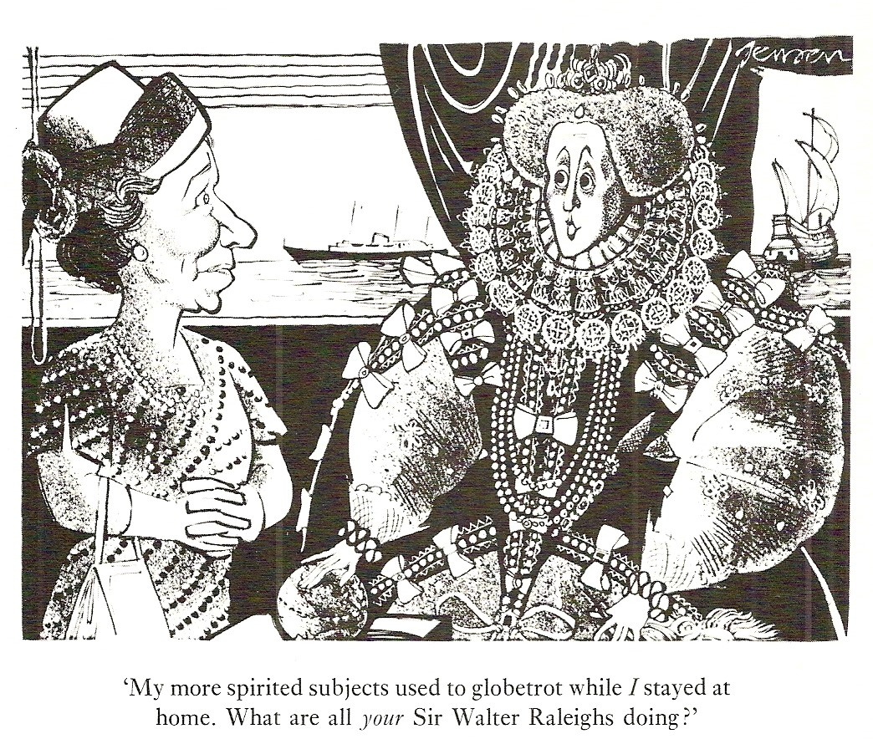

Queen Elizabeth I to Queen Elizabeth II: “My more spirted subjects used to globetrot while *I* stayed at home. What are all your Sir Walter Raleighs doing?”

* * * * * * * * * * *

**JUNE 2019**

|  |  |  |  |  |  |  |
| --- | --- | --- | --- | --- | --- | --- |
| **SUNDAY** | **MONDAY** | **TUESDAY** | **WEDNESDAY** | **THURSDAY** | **FRIDAY** | **SATURDAY** |
| FHC = Family Holy Communion | THC = Traditional BAS Holy Communion | PEC = Parish Executive Committee | BAS = Book of Alternative Services |  |  | 1  **8:00 AM**  **Plant, Yard, Garage Sale Extravaganza** |
| 2  **7th Sunday of Easter**  9:30 AM  FHC  **Cemetery Sunday**  11:00 AM  THC | 3 | 4  8:00 AM Kiwanis | 5  1:00 PM Darts  7:00 PM PEC | 6  10:00 AM  Tai Chi  5:00 PM  Irish Dancing | 7  10:15 AM  Earth Drum | 8 |
| 9  **Day of Pentecost**  10:30 AM  FHC  then **Church Picnic** | 10 | 11  8:00 AM Kiwanis | 12  9:30 AM Prayer  Shawl  1:00 PM Darts | 13  10:00 AM  Tai Chi  5:00 PM  Irish Dancing | 14  10:15 AM  Earth Drum | 15 |
| 16  **Trinity Sunday**  **Father’s Day**  10:30 AM  FHC  followed by Special Vestry Meeting | 17 | 18  8:00 AM Kiwanis | 19  1:00 PM Darts | 20  10:00 AM  Tai Chi  5:00 PM  Irish Dancing 6:00 PM  Painswick Horticultural | 21  10:15 AM  Earth Drum | 22 |
| 23  **2nd Sunday after Pentecost**  10:30 AM  FHC | 24 | 25  8:00 AM Kiwanis | 26  1:00 PM Darts | 27  10:00 AM  Tai Chi  5:00 PM  Irish Dancing | 28 | 29 |

**See June 30 on next calendar page.**

**JULY 2019**

|  |  |  |  |  |  |  |
| --- | --- | --- | --- | --- | --- | --- |
| **SUNDAY** | **MONDAY** | **TUESDAY** | **WEDNESDAY** | **THURSDAY** | **FRIDAY** | **SATURDAY** |
| 30  **3rd Sunday after Pentecost**  10:30 AM  FHC | 1  **Canada Day** | 2  8:00 AM Kiwanis | 3  1:00 PM Darts | 4  10:00 AM  Tai Chi  5:00 PM  Irish Dancing | 5  10:15 AM  Earth Drum | 6 |
| 7  **4th Sunday after Pentecost**  10:30 AM  Hymn Sing | 8 | 9  8:00 AM Kiwanis | 10  9:30 AM Prayer  Shawl  1:00 PM Darts | 11  10:00 AM  Tai Chi  5:00 PM  Irish Dancing | 12  10:15 AM  Earth Drum | 13 |
| 14  **5th Sunday after Pentecost**  10:30 AM  FHC | 15 | 16  8:00 AM Kiwanis | 17  1:00 PM Darts | 18  10:00 AM  Tai Chi  5:00 PM  Irish Dancing | 19  10:15 AM  Earth Drum | 20 |
| 21  **6th Sunday after Pentecost**  9:30 AM  Morning Prayer | 22 | 23  8:00 AM Kiwanis | 24  1:00 PM Darts | 25  10:00 AM  Tai Chi  5:00 PM  Irish Dancing | 26  10:15 AM  Earth Drum | 27 |
| 28  **7th Sunday after Pentecost**  10:30 AM  FHC | 29 | 30  8:00 AM Kiwanis | 31 |  |  |  |

**AUGUST 2019**

|  |  |  |  |  |  |  |
| --- | --- | --- | --- | --- | --- | --- |
| **SUNDAY** | **MONDAY** | **TUESDAY** | **WEDNESDAY** | **THURSDAY** | **FRIDAY** | **SATURDAY** |
|  |  |  |  | 1  10:00 AM  Tai Chi  1:00 PM  Parish Drop In  5:00 PM  Irish Dancing | 2  10:15 AM  Earth Drum | 3 |
| 4  **8th Sunday after Pentecost**  10:30 AM  Morning Prayer | 5  **Civic Holiday** | 6  8:00 AM Kiwanis | 7  1:00 PM Darts | 8  10:00 AM  Tai Chi  5:00 PM  Irish Dancing | 9  10:15 AM  Earth Drum | 10 |
| 11  **9th Sunday after Pentecost**  10:30 AM  FHC | 12 | 13  8:00 AM Kiwanis | 14  9:30 AM Prayer  Shawl  1:00 PM Darts | 15  10:00 AM  Tai Chi  1:00 PM  Parish Drop In  5:00 PM  Irish Dancing | 16  10:15 AM  Earth Drum  **Deadline for articles for *St. Paul's***  ***Chronicle*** | 17 |
| 18  **10th Sunday after Pentecost**  10:30 AM  Hymn Sing | 19 | 20  8:00 AM Kiwanis | 21  1:00 PM Darts | 22  10:00 AM  Tai Chi  5:00 PM  Irish Dancing | 23  10:15 AM  Earth Drum | 24 |
| 25  **11th Sunday after Pentecost**  10:30 AM  FHC | 26 | 27  8:00 AM Kiwanis | 28  1:00 PM Darts | 29  10:00 AM  Tai Chi  5:00 PM  Irish Dancing | 30 | 31 |

**CHILDREN’S COLOURING PAGES**

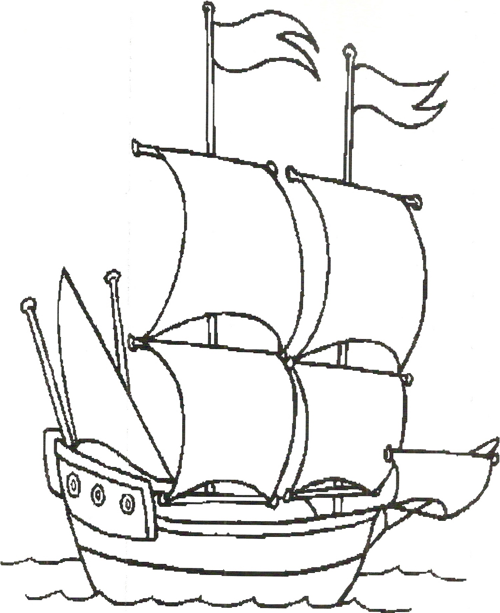



**Afternoon Tea Party and Fashion Show – Saturday, April 13, 2019**

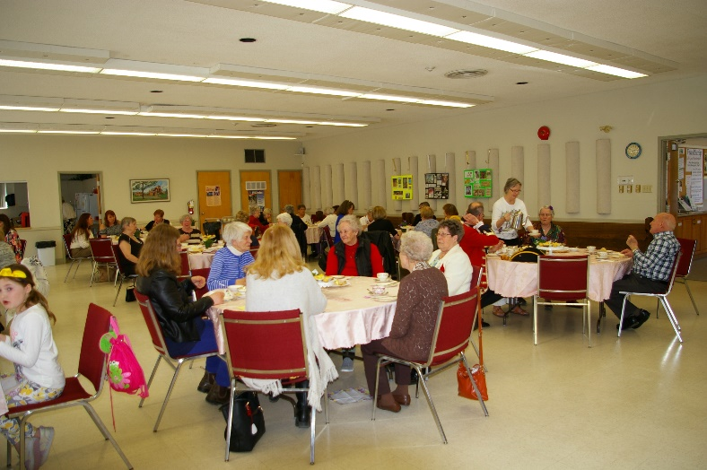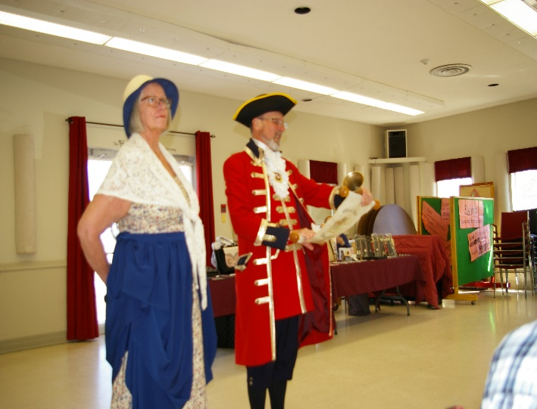

Barrie City Crier, Stephen Travers, reads People attending the Tea Party.

the proclamation, with his wife, Linda.

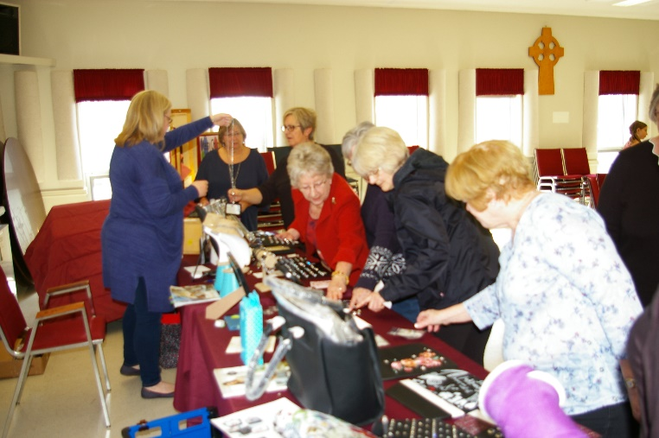

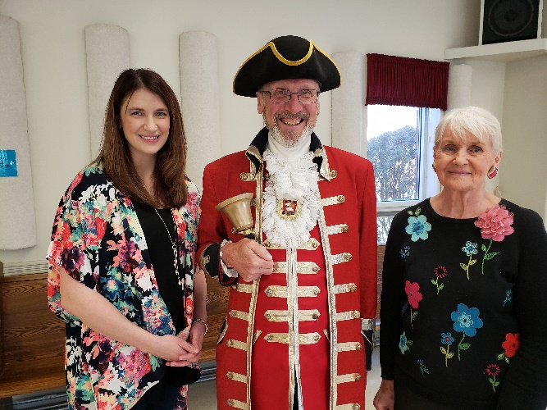

Jewellery examined and maybe bought? Kat Ward, City Crier Stephen

Travers, and Marilyn Jenkinson

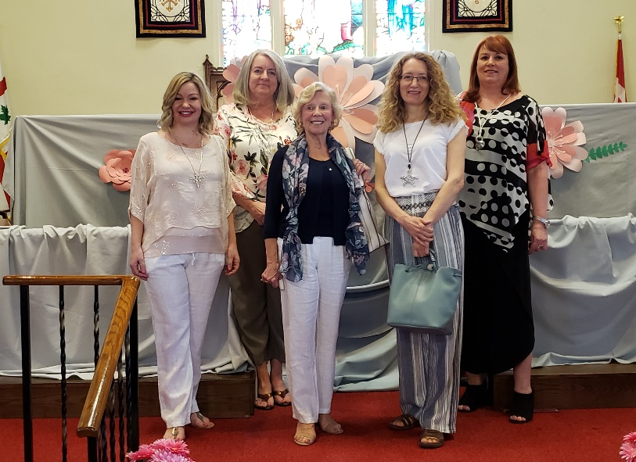

Left: Our Models:

Siobhan Duncan-Kemp,

Cathy Turgeon, Barb Martin,

Frances Oakley Marshall

and Cindy Starnino

**Mother’s Day Dinner – Saturday, May 11, 2019**

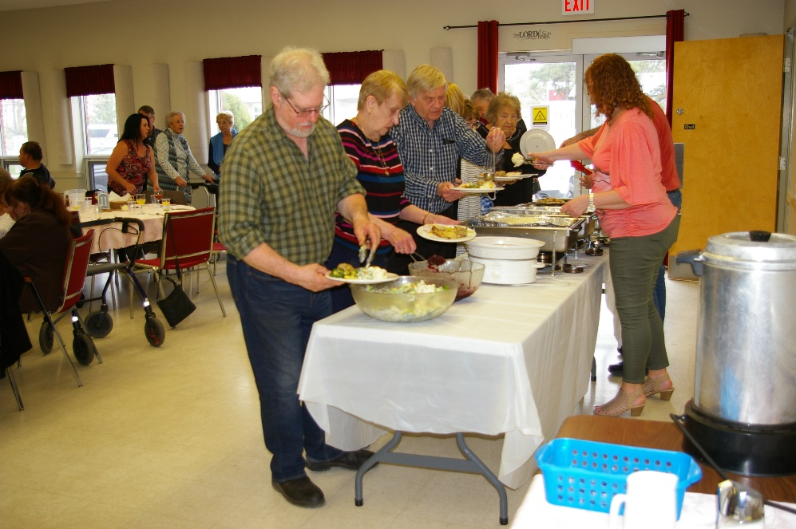

A wonderful dinner

is served.

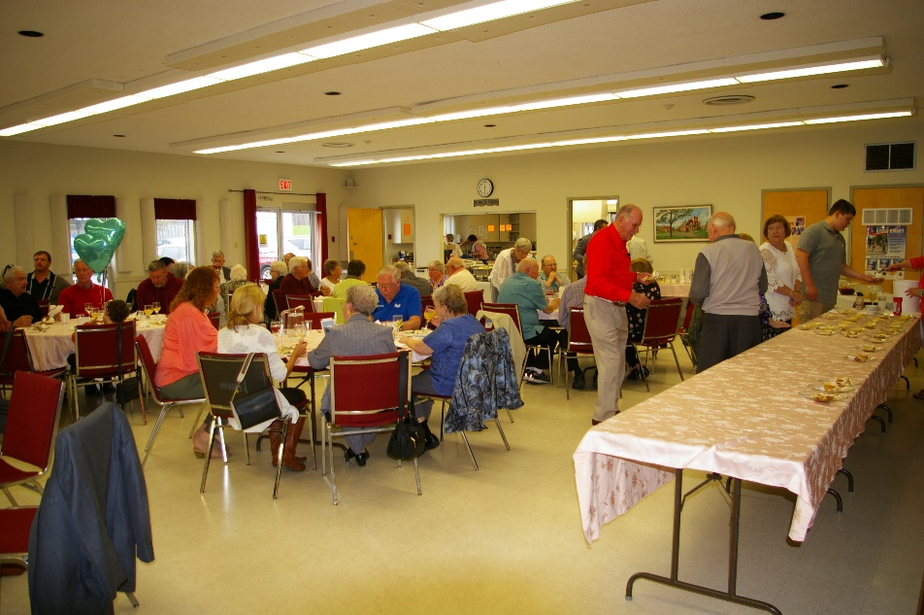

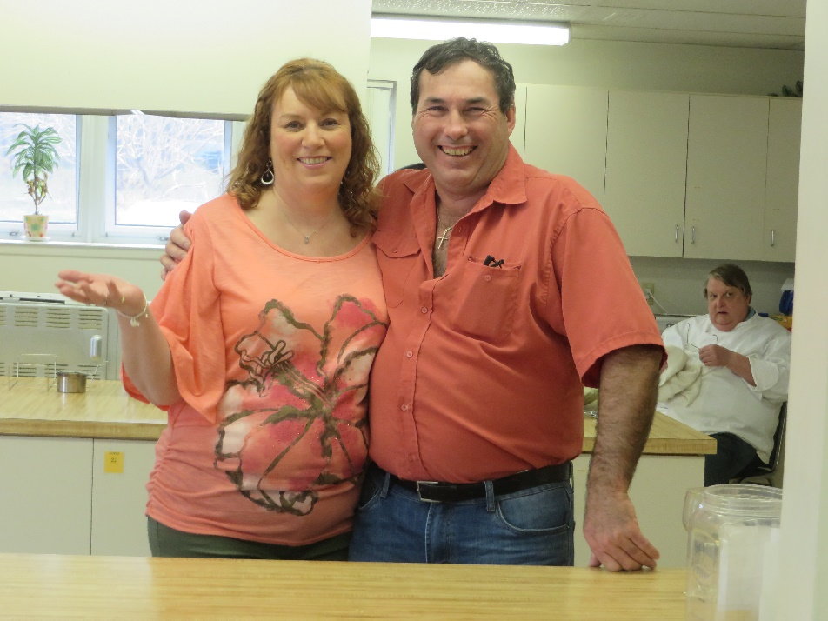

Our chefs: Mike Sindrey, Cindy Starnino, and Father Ken Rouguska. Thank you. A great dinner!